Judaic Studies Homework: Due Friday, September 7, 2018
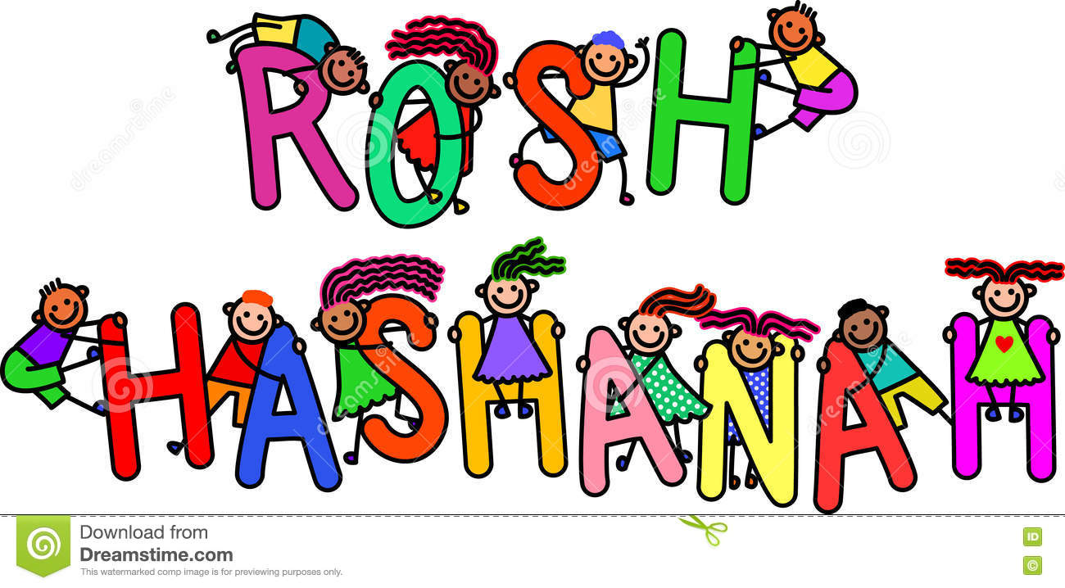
Use the table to brainstorm all of the things you know about Rosh Hashanah.

Apples and honey | You eat these to symbolize a sweet new year.

